

**Exam Boost Workshops T3 & T4 and October Holiday Courses**

**Exam Boost Workshops in Term 3 & 4 for Years 11 & 12**

**Exam Boost Workshops** delivers subject-specific, targeted, exam preparation in the weeks leading up to exams. In one day, each workshop packs in 6 hours of exam focused teaching from a WACE exam marker, with the goal of boosting student’s exam technique and performance.

|  |  |
| --- | --- |
| * Targeted exam preparation * Learn exam techniques and strategies to boost exam performance * Insights into the exam marking guide * Practise answering exam-style questions * Receive feedback from a qualified exam marker   **Venues:** All Saint’s College, Perth Modern School and Online. |  |

# ATAR October Holiday Revision Program for Years 11 & 12

ATAR Revision Courses provide students thorough subject revision and exam question practice to give the best possible preparation for exams. Our courses to help maximise grades and boost confidence before exams. Courses are **10-hours (2 hrs a day, over 5 days)** in **ATAR subjects**, plus specially designed **Essay Writing and Study Skills courses are available.**

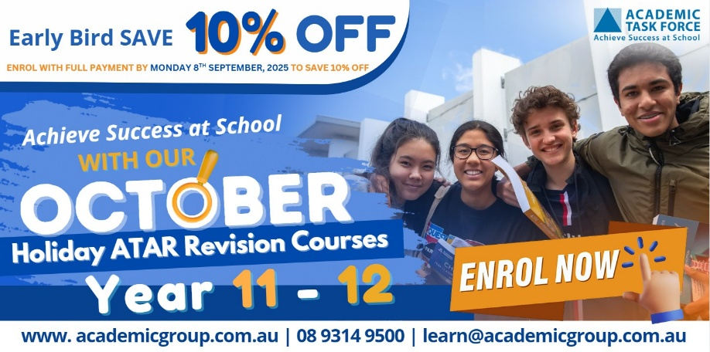

|  |  |
| --- | --- |
| * Comprehensive revision of Semester 1 & 2 content. * Boost confidence, knowledge and understanding. * Guidance from a highly qualified ATAR subject-specialist teacher and feedback on your work. * Become familiar with and understand a variety of * exam -style questions. * Receive a course workbook to help revise at home. * An engaging and interactive learning environment   **Courses available** at All Saint’s College, rrrrrrChurchlands SHS and Online |  |

**Early bird 10% discount on Holiday Programs ends Monday, Sept 8th, 2025**

[**View our timetable and enrol online:**](http://www.academicgroup.com.au/) **www.academicgroup.com.au**

**Enrol online:**

[**www.academicgroup.com.au**](http://www.academicgroup.com.au)

**Call: 9314 9500**

**learn@academicgroup.com.au**