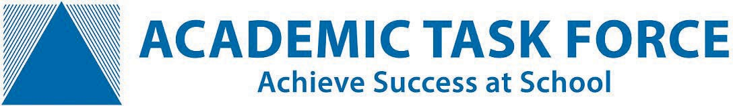
Term 4 Exam Boost Workshops & Tuition.
Enrol online:
www.academicgroup.com.au
Call: 9314 9500
learn@academicgroup.com.au
Exam Boost Workshops

Exam Boost Workshops for Students in Years 11 & 12

Exam Boost Workshops provide subject-specific, targeted, exam preparation in the weeks leading up to exams. In one day, each workshop packs in 6 hours of exam focused teaching from a WACE exam marker, with the sole purpose of boosting student’s exam technique and performance. Students will individually receive feedback on how to improve their answers and results. Term 4 Exam Boost Workshops run from 12th to 27th October.

- Targeted exam preparation  - Learn new exam techniques  - Strategies and problem solving methods to boost your exam performance  - Insights into the exam marking guide  - Practise answering exam-style questions  - Receive feedback from an experienced exam marker  Venues: Churchlands SHS, Rossmoyne SHS,  Perth Modern School, and Online. | 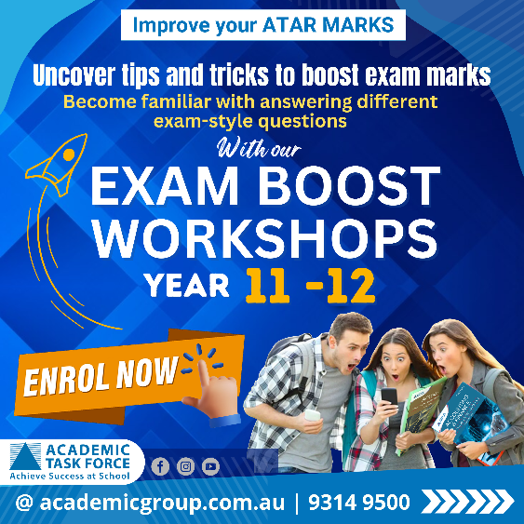
To enrol: https://academicgroup.com.au/course/exam-boost-seminars/

_______________________________________________________________________________________________

Enrolments are now open for Term 4 - Year 7- 10 Tuition in Maths, Science and English and ATAR Tuition.

Tuition for Years 7-10
Academic Task Force offers Year 11 & 12 ATAR Tuition and Year 7- 10 Tuition in Maths, Science and English. Taught by fully qualified subject-specialist teachers in small groups of 2-4 students, each student will benefit from lots of individual attention and targeted help.

What do you get with Tuition?  - An expert and qualified teacher  - Weekly individual help  - (2-4) students.  - Tailored Tuition to your specific needs and goals  - Tuition aligned with the WA syllabus  - Feedback on your child's progress each term  Venues:  Venues: Churchlands SHS, Rossmoyne SHS and Perth Modern School  Enrol Today: ATAR Tuition or Year 7- 10 Tuition | 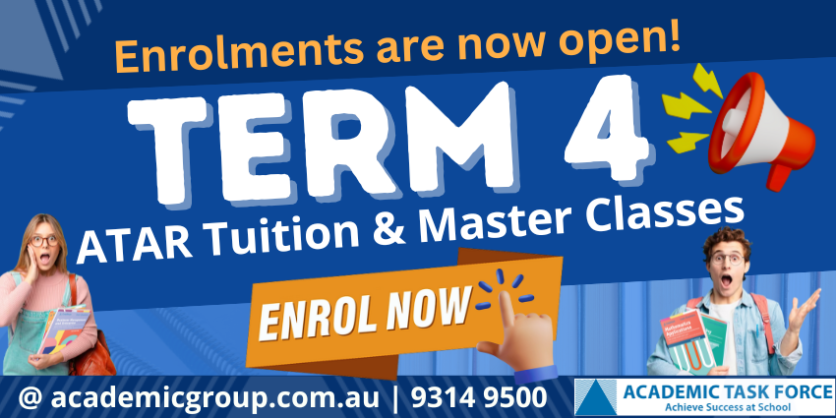

Enrol online:
www.academicgroup.com.au
Call: 9314 9500
learn@academicgroup.com.au

