www.academicgroup.com.au | learn@academicgroup.com.au | 9314 9500

ATAR Revision and Skills Development Courses

April Holidays – ATAR Revision Courses for Years 11-12
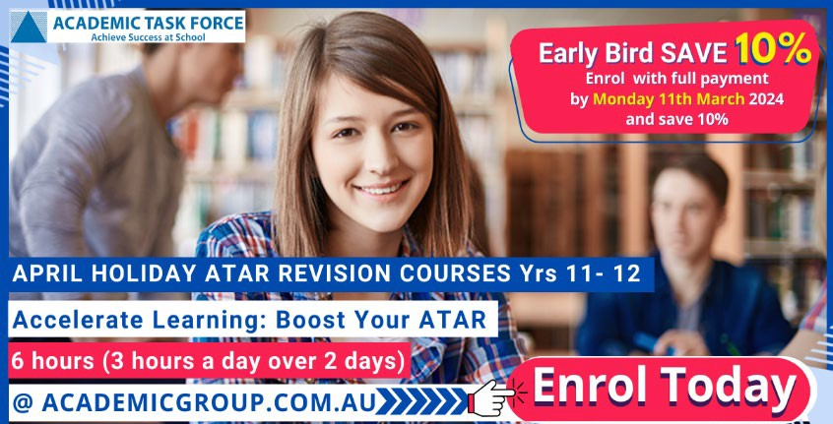
Increase your confidence and prepare for exams with our April Holiday ATAR Revision Courses. Each course is 6-hours (3 hours per day, over 2 days) and will provide thorough subject revision and exam question practice to give you the best possible preparation for Semester 1 exams.

With our ATAR revision courses you will receive:
- Interactive course revision and exam preparation led by qualified subject specialists.
- In-depth review of the syllabus.
- Exam practice and preparation.
- Quality course notes to support and extend study and revision.
We also offer courses in:
Study Skills: Learn how to study effectively and spend less time studying. We teach you how to improve your time management, goal setting, reading strategies, exam and stress management techniques.

Essay Writing: In only 6 hours learn essay writing skills that will refine your writing skills for life. You will learn how to create great essays using a structure that can be adapted to any subject.

Venues: Churchlands SHS, Rossmoyne SHS, Perth Modern School and Online.

April Holidays – Skills Development Courses for Years 7-10
Courses available in English, Maths, Science, Essay Writing , Learning Skills and Creative Writing. Each course is 6-hours (3 hours per day, over 2 days) and is taught by a specialist, qualified teacher who will help build your confidence and develop the skills needed to succeed in high school.
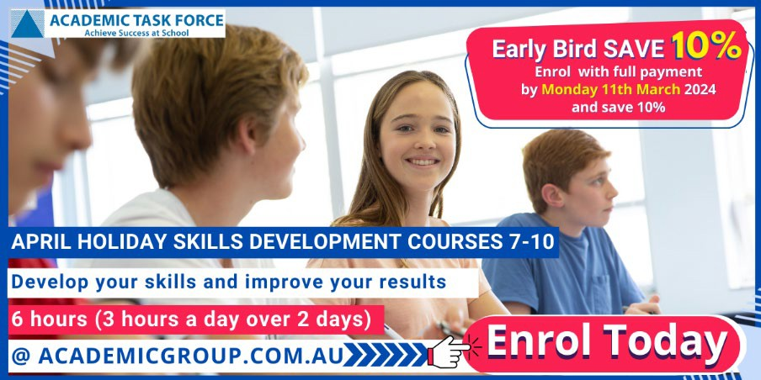
Improve your school results:
- Increase your confidence and school performance
- Revise subject concepts and build skills
- Receive expert teaching from subject specialists

Venues: Rossmoyne SHS and Churchlands SHS

Early Bird SAVE 10% Enrol with full payment by Monday, March 11th to SAVE 10%

